A SYSTEMATIC APPROACH TO GEOTHERMAL POWER CLASSIFICATION

Richard J. Erdlac, Jr.¹, Peter Gross², and Edward McDonald³

¹Energy America Geothermal, 303 Veterans Airpark Lane, Suite 4101, Midland, TX 79705
²Energy America Geothermal Power Division, 3200 Wilcrest Dr., Ste. 450, Houston, TX 77042
³Energy America Geothermal, 8100-M4 Wyoming Blvd NE #430, Albuquerque, NM 87113

Keywords: geothermal energy, geothermal power, co-produced, stranded, geothermal classification, volcanic terrain, non-volcanic terrain, sedimentary basins

Abstract
Multiple classification schemes have been devised to explain and categorize geothermal energy systems. Example classifications include those developed by the United States Geological Survey, National Renewable Energy Laboratory, and through a study conducted at the Massachusetts Institute of Technology. These classification systems have mixed geology, engineering, and resource terminology together in a manner that is difficult to present to an investor or to someone not familiar with the geothermal industry. Neither are these classifications conducive as a generalized exploration tool that relate the heat and moveable water to a geologic province or feature as a potential exploration target. This paper presents a first attempt at developing a broad geothermal power classification system that structures various parameters impacting geothermal development to the geological environment.

Introduction
Classification systems are the heart of organizing data and information in a manner that can be used by others in decision making processes. Very often this information is classified in multiple ways, depending upon the needs and the use of the final classification system. This is best understood by a specific geologic example.

Various geology books and articles that discuss carbonate rocks will reference different classification schemes, some of which are specifically derived for the work being discussed. Two of the best known and used are the Dunham and Folk carbonate classification systems. Both classification systems subdivide limestone on the basis of content, but each scheme approaches the classification from different perspectives.

The limestone classification devised by Folk (1959) is extremely suitable to thin section study (Figure 1). The original classification subdivided the constituents of limestone into three groups: particles of sand size or larger, micrite (or mud), and cement. All of the particles are termed allochems whereas the cement, known as sparry calcite, and micrite are the orthochems. The limestone name will incorporate one or more of the allochems along with the matrix cement type. Further subdivision is possible based upon the percentage of constituents within the limestone. By contrast the Dunham (1962) classification system focuses on depositional texture and is well suited for rock descriptions that use a hand lens or binocular microscope (Figure 2). In this system nomenclature is based on whether the rock is mud or grain supported. Both of these classification systems have been modified by other researchers to suit various needs of limestone description.

Geothermal energy categorizations are no different in that several schemes have been devised by various organizations covering the entire geothermal spectrum. This includes geoexchange, direct use, and power generation from geothermal energy, often being combined in a single classification system. These classifications simultaneously combine geological environments, energy resource type, and the engineering approach to production in a potpourri that can make presentation to investors confusing. Similarly, the use of these categories as exploration tools for targeting geologic regions for heat production is questionable. This paper presents an alternative arrangement that separates the elements of geothermal energy and presents a descriptive geopower classification.

Historic Geothermal Classification
The broadest geothermal classification and the easiest to understand is discussed at the Geo-Heat Center at the Oregon Institute of Technology (http://geoheat.oit.edu/whatgeo.htm). This classification is based entirely on temperature ratings of low (<90ºC or 194ºF), moderate (90 – 150ºC or 194 – 302ºF) and high (>150ºC or >302ºF), and is loosely tied to the potential uses of the geothermal heat energy. This classification approach is important for the public who is familiar with temperature, but has limitations among professionals.

At least four other classification systems were suggested by different organizations over the last 30+ years of geothermal investigations. These schemes were devised to describe geothermal resource type using scientific and engineering terms that are more closely related to the geology of the resource when compare to a solely temperature based description.

In the 1970’s the United States Geological Survey (USGS) produced two important publications reviewing the potential geothermal resources available in the United States. Circulars 726 (White and Williams, 1975) and 790 (Muffler, 1979) are landmark publications because they discussed potential sites in the U.S. for geothermal development and they attempted to link the resource to geologic environments.

A side-by-side comparison of these two classifications, as provided in Circular 790, demonstrates many similarities and a few differences (Table 1). Circular 726 defined three broad categories that included conduction, igneous, and hydrothermal systems, whereas Circular 790 defined five separate categories of conduction, geopressured, igneous, hydrothermal convection, and low-temperature systems. Circular 726 incorporated the geopressured resource within the conductive system, and the igneous system included energy directly from molten systems. This earlier circular did not include the low-temperature resource as a category for consideration. The thought behind the molten igneous system was the proposed drilling into (or very near) a subsurface liquid magma chamber for heat extraction. However problems such as how to keep the drill bit from melting or at best failing to cut through the region of very high temperatures made this idea impractical, and it was subsequently dropped from Circular 790.

These two classification systems have been extensively used as exploration for geothermal resources has progressed. In 2006 and 2007 two variations on these earlier classification systems were suggested by the National Renewable Energy Laboratory (NREL) (Green and Nix, 2006) and the Massachusetts Institute of Technology (MIT) (Tester, 2007) respectively (Table 2). Both of these categories were developed for the purpose of gaining understanding of the existing geothermal resource base available and the estimated accessible and developable resource within the next 40 years or so.

The deep geothermal category of NREL included all of the conduction-dominated enhanced (engineered) geothermal system (EGS) resource as defined by MIT, which included sedimentary, crystalline basement, and supercritical volcanic EGS rocks. NREL broke hydrothermal into two classifications based on temperature and whether the resource has been identified. Finally, NREL listed co-produced and geopressured resources as related to deep oil and gas wells together whereas MIT broke these resources into two separate categories.

The two USGS along with the NREL and MIT categories present classifications that combine the geologic environment, with the resource type, and the mechanism of heat transfer and recovery. Considering that geothermal power production is the most costly form of geothermal energy development, it is best to have a classification that is focused on power production rather than attempting to incorporate geothermal HVAC and direct use with power development.

Geothermal Power Classification
The need for a new geothermal power classification can be justified by looking at sedimentary basins for geothermal power development. In many instances where wells were plugged and abandoned (P&A’d), hot water can easily exist behind pipe in either a geopressured or a hydrostatic condition, the determination being based solely on the pressure that might be found in the subsurface (Figure 3). This is a different situation from hot water being coproduced with oil and/or gas (McKenna, et al., 2005). The name “stranded geothermal resource” began being used within company discussions to describe an energy resource left behind when a well is P&A’d. The term stranded could then refer to either geopressured or hydrostatic resources depending on formation pressure.

In defining a geothermal power classification system, five key parameters were considered important for classifying the resource (Table 3). These include the geologic environment, geologic features, the crustal “heat source”, the resource category, and the rock type in which the geothermal resource is found. Each of these parameters is discussed below.

Geologic Environment / Feature
On a global scale geothermal energy is tied to the geologic environment and the large scale features specific to that environment (Table 3). The importance of plate tectonics to geology leads to the first category being plate margin and intraplate related environments. The plate margin environment was further subdivided into convergent (compressional), divergent (extensional), and transform (strike-slip) environments. Within each of these environments various large scale geologic features exist that represent the target regions for geothermal power exploration.

A convergent environment, along with the related subduction complex, has large scale features that include back arc basins, a volcanic arc complex, continental volcanism, and an intrusive complex. Active back arc basins include the Marianas, Manus, North Fiji and Lau Basins in the western Pacific, the Okinawa Trough Basin west of the Japan Islands, the Tyrrhenian Sea west of Italy, and the East Scotia Sea east of the southern tip of South America in the Atlantic Ocean. Volcanic arc complexes exist as a curved volcanic island chain where oceanic crust on one plate subducts beneath oceanic crust of a second plate (i.e. Aleutian, Japanese, or Soloman Islands). By contrast, continental volcanism is the result of oceanic crust subducting beneath continental crust, examples of which include the Andes and Cascade volcanic zones. Finally, intrusive complexes would represent the subsurface igneous masses that feed surface volcanism and would be more readily found in oceanic-continent and continent-continent collision regions.

The divergent environment includes volcanic spreading centers and rift systems. Volcanic spreading centers and rift systems can be genetically related; however spreading centers are usually referenced to active plate margins where plates are diverging along a mid-ocean ridge that is generating new oceanic crust whereas a rift system is related to extension along a long narrow trough within a continent that may be related to active or failed continental breakup. The Mid-Atlantic ridge, Gulf of California, and the Red Sea represent several of the mid-ocean spreading centers presently in existence. The Mid-Atlantic Ridge has several islands that include Iceland, the Azores, and Ascension Island representing land masses along the ridge, with Iceland being the largest island and taking full advantage of its position for geothermal development. Rift systems, as continental features, would include areas such as the East African Rift and possibly the Rio Grande Rift along with deep associated magmatic activity, such as that found under Socorro, New Mexico.

The transform or strike-slip system environment can show various features that include pull-apart basins, transtensional faulting, and localized volcanic and/or magmatic (intrusive) centers associated with deep faulting. Examples of well formed transform systems include the San Andreas Fault and the Dead Sea Transform systems. A pull-apart basin is a specific feature related to en-echelon faults where the basin forms within the area bracketed by the staggered fault boundaries. These basins can show many thousands of feet of structural relief, with thick sediments infilling the basin. The central floor of this basin can contain volcanic material from outpourings during early stages of development prior to subsequent sedimentary burial. The Dead Sea area displays a very well developed example of a pull-apart basin. Transtensional faulting occurs along a strike-slip system when a component of extension exists along what would otherwise have been primarily a simple shear system. The Walker Lane fault system appears to be an example of a transtensional strike-slip system, sharing its motion with that of the San Andreas Fault. Various Oligocene through upper Miocene ash-flow tuffs, andesite and dacite lavas and intrusives, and basaltic andesite lavas in proximity to the Walker Lane in the Hawthorne, Nevada region suggests that deep fault control provided surface accesses to this volcanic activity.

The intraplate environment represents areas that are not presently along or very near active plate margin environments. Features of this type are represented by mantle plumes or hot spots, cratonic basins, passive margin basins, extensional terrain, and the basement complex. Mantle plumes represent areas of surface volcanic activity 100 to 200 km across that persist for several tens of millions of years, and whose origin may be from the lower part of the Earth’s mantle. Examples of mantle plumes include the Hawaiian Islands and the hot spot associated with Yellowstone along with the train of volcanic outpouring associated with this hot spot into Idaho. The term extensional terrain is used for regions removed from existing plate margins and cover large areas in width and length. The prime example of this terrain is the Basin and Range Province located in the North American Cordillera. Stretching of the crust has allowed synextensional magmatism to heat the region, resulting in higher heat flow over a broad region. The craton represents those parts of a continent that has attained stability and has been little deformed for a long time. This definition includes both shield and platform areas of a continent. Cratonic basins are sub circular basins that lie wholly or partly on continental crust of granitic origin. Cratonic basins are represented by areas such as the Permian Basin or Illinois Basin. Passive margin basins represent areas such as the present day Gulf of Mexico where great thicknesses of sediments have accumulated above a more ancient rift system that is now marked by a continent-ocean boundary. Finally the basement complex represents an undifferentiated rock assemblage that underlies the oldest stratified rocks in a region. The complex may be crystalline or metamorphosed, can be of Precambrian age but can also be of much younger age. An example of this type of feature is the Cooper Basin area of Australia, where heat is described as produced in granite and maintained by overlying rocks that act as an insulating heat blanket.

Crustal Heat Source
The interior heat of the Earth is derived both from primordial sources related to the formation of the Earth and to processes that continue to generate heat internally (Beardsmore and Cull, 2001). The dominant source of this interior heat is from the decay of radioactive elements, primarily uranium (²³⁸U), thorium (²³²Th), and potassium (⁴⁰K), located within the mantle and the crust of the Earth. More localized heat sources also exist, such as frictional heating along faults and at plate boundaries. Regional metamorphism will have both endothermic and exothermic reactions. At low temperature, a high shear stress is possible within a rock and the exothermic reaction will dominate. This changes as temperature increases, with the reaction becoming increasingly endothermic.

In using the term “crustal heat source”, however, the present context is one of identifying the immediate material or process that provides heat or that can be tapped for extracting heat to generate electricity. Magmatic activity would tend to dominate along plate margin environments. In these regions the depth into the Earth to which tectonic activity occurs provides conduits for magma to rise into the crust that in turn heats a broad region or provides more local sources of heat. Magmatic activity would also be dominant in the intraplate environment where mantle plumes and extensional terrain is found.

Within most sedimentary basin environments magmatic activity is not a source of heat. Yet as depth increases in a basin the measured temperature within the sedimentary rocks of that basin will increase. This increase in temperature is related to various factors such as changes in thermal conductivity of the rock under pressure, changes in rock porosity, the amount and type of fluid found within the rock, along with potential variations in the basement complex that affect heat flow through the rock.

The thermal gradient relates the heat flux (flow per unit area per unit time) through a medium to the thermal conductivity of a medium, and does not act as a generator of heat in the Earth. In the case of heat extraction from a hot, porous reservoir where water is movable and extractable from the formation, the act of removing the water and associated heat perturbs the local temperature by creating a cool spot. If the rate of heat removal remains constant, then a continuous flow of heat will be established into this disturbed region as a thermal gradient is established between this cooler location and the hotter rock surrounding this site. Hence, the thermal gradient becomes an ad hoc source of heat that is extractable for power generation.

Basement rocks such as granite contain higher concentrations of radiogenic minerals when compared to other types of crystalline rocks. Heat generated within these rocks becomes a target for extraction if overlying rock strata have lower conductivity and act as a thermal blanket, trapping the heat within the granite, not allowing it to readily escape.

Resource Category
While the previous parameter addresses the local source of heat, the resource category references the medium within which the heat is to be found and produced. Tapping heat within the plate margin environment and within mantle plumes and extensional features will be dominated by steam and/or hydromagmatic production. The term steam is used here to reference a vapor-dominated system of which Larderello, Italy and The Geysers, California are the prime examples. This resource has temperatures on the order of 240ºC or more (White and Williams, 1975). Hydrothermal can be used to describe any hot water or steam resource (Wohletz and Heiken, 1992), though some have restricted its use to water of magmatic origin. With the advent of potential hot water use from sedimentary basins where magmatic activity is absent, a separation in terms involving “hot water” is necessary. This paper adopts the term hydromagmatic (Wohletz and Heiken, 1992) which is restricted to the interaction of meteoric or connate water with magma or magmatic heat.

Within sedimentary basins, two distinct geothermal resource categories are suggested: stranded and co-produced. The stranded geothermal resource represents warm to hot fluid that is in a geopressured or hydrostatic condition that was not produced when the basin was drilled originally for oil and gas. This fluid is still behind pipe waiting to be produced due to the fact that the last fluid that an oil or gas company wants to produce is water, regardless of temperature. Production of too much water can adversely affect the production of the oil or gas, let alone the disposal costs that exist for the produced water.

A stranded geopressured resource consists of hot brine often saturated with methane and found in large, deep aquifers that are under higher pressure due to water trapped in the burial process (Figure 3). These resources are often found in sedimentary strata at depths of 3km to 6 km. Water temperature can range from 90ºC to 200ºC. Three forms of energy, thermal, hydraulic from the high flow pressure, and chemical from burning the dissolved methane, are potentially obtainable from this resource. The stranded hydrostatic resource represents a generally lower pressured environment (Figure 3) where hot water will not flow the entire way to the surface but which requires a submersible pump in the well to assist in obtaining the high volume water flow necessary for sufficient heat extraction.

By contrast a co-produced fluid is water that is produced along with oil and/or natural gas. In these cases the well may be sufficiently old that greater amounts of water are now being produced but with hydrocarbon volumes for the well to remain economical. In other instances a well may be drilled primarily for gas but the reservoir is water wet with the gas dissolved in the water. Production of the water results in the gas coming out of solution but still with significant amounts of water production. If the water is sufficiently hot and the flow volume is sufficiently high then electric power can probably be produced at a low megawatt output.

The hot dry rock (HDR) category represents rock absent of water but with high heat that it can be produced if a fluid is injected into the rock to act as a carrier for the heat. This resource is huge in comparison to other categories. Past difficulties with HDR technology has been the acquisition of heat, whereby cool zones are generated along induced fractures where water has been injected to acquire and transport the heat. However, continued investigations worldwide into HDR technology may yet result in this resource being very valuable. Much of the world’s deep basement complex is associated with the HDR category.

Rock Type
Only three broad rock types exist from which geothermal can be potentially extracted – igneous, metamorphic, and sedimentary. At present, sedimentary and igneous rocks are the prime candidate rock categories that are drilled for geothermal extraction. These two rock types are found in different amounts within the various geologic environments worldwide. They form the reservoir that contains the hot resource from which geothermal energy is extracted. Each of the individual igneous and sedimentary rock types have mechanical and thermal properties that will impact the rate of drilling, the natural porosity and permeability of the reservoir, and the heat transfer rate and mechanism active in the subsurface environment.

Convergent and divergent environments, along with mantle plume and extensional features, are probably dominated by igneous rock (intrusive and extrusive) as targets for geothermal development, with sedimentary rocks playing a secondary role as a reservoir. Transform environments most likely have equal potential from both igneous and sedimentary strata. Basins are dominated by sedimentary rock as the target reservoir, while igneous rocks are the target for the basement complex.

Discussion And Conclusions
Assessing the basis of data categorization is important for building a clear and concise set of concepts that can be readily articulated when communicating with others. So long as geothermal energy remained in the realm of volcanic and ore body environments, existing classifications have sufficed for geothermal development. However expansion to sedimentary basins requires a reconceptualization of classification that is more encompassing in its geologic realm. Similarly the mixed potpourri of various geologic, engineering, and resource terminology makes expansion of existing classifications into sedimentary basins cumbersome. Thus the proposed geothermal power classification system (Table 3) is a first step in developing a scheme that is defined by specific key geologic parameters that organize pertinent data into a more fluid and functional manner, one that can hopefully begin to be used as an exploration as well.

This systematic, descriptive approach is not necessarily the definitive answer to geothermal data organization. For example heat transfer mechanisms were not included in this discussion. The presence or absence of other surface or subsurface features affecting or resulting from geothermal activity in various geologic environments was not discussed. While the broad categories of igneous and sedimentary rocks was mentioned as related to geologic features, a detailed break down of the rock strata (i.e. limestone, sandstone, andesite, rhyolite, etc.) is necessary for a more complete classification. Neither has permeability and porosity variations within the various target rock types been presented. Thus input from other professionals is welcome and desired so that a comprehensive classification system for power generation may ultimately be developed. The importance of such an approach will aid in teaching future students about geothermal exploration, and when presenting background information to aid non-geologic professionals in grasping the various nuances of geothermal power development.

Acknowledgements
This work is the outcome of discussions by the authors at Energy America Geothermal while developing prospective areas for power generation and financial strategies for these same geothermal areas. We are grateful to suggestions by GRC reviewers Guy Nelson and John Lund. We especially thank James Witcher for a critical technical review both in writing and with the senior author via phone. His suggestion to reorganize along a plate tectonic approach was most helpful.

References
Beardsmore, G.R., and J.P. Cull, 2001, Crustal heat flow: A guide to measurement and modeling; Cambridge University Press, 324 p.
Dunham, R.J., 1962, Classification of carbonate rocks according to depositional texture, in W.E. Ham (ed.), Classification of carbonate rocks: American Association of Petroleum Geologist Memoir 1, p. 108-121.
Friedman, G.M. and J.E. Sanders 1978, Principles of sedimentology: John Wiley & Sons, New York, 792 p.
Folk, R.L., 1959, Practical petrographic classification of limestones: American Association of Petroleum Geologists Bulletin, v. 38, p. 1-38.
Green, M.D. and R.G. Nix, 2006, Geothermal – The energy under our feet: Geothermal resource estimates for the United States: National Renewable energy Laboratory Technical Report TP-840-40665, 17 p.
McKenna, J., D. Blackwell, and C. Moyes, 2005, Geothermal electric power supply possible from Gulf Coast, Midcontinent oil field waters: Oil and Gas Journal, Week of Sept. 5, p. 34-40.
Muffler, L.J.P. (ed.), 1979, Assessment of geothermal resources of the United States – 1978; United States Geological Survey Circular 790, 163 p.
Norwood, Jr., E.M. and D.S. Holland, 1974, Lithofacies mapping a descriptive tool for ancient delta systems of the Louisiana outer continental shelf: Gulf Coast Association Geological Societies Transactions, v. 24, p. 175-188.
Tester, J.W. (chair), 2007, The future of geothermal energy: Impact of enhanced geothermal systems (EGS) on the United States in the 21st century: Massachusetts Institute of Technology, 366 p.
White, D.E. and D.L. Williams (eds.), 1975, Assessment of geothermal resources of the United States – 1975; United States Geological Survey Circular 726, 155 p.
Wohletz, K., and G. Heiken, 1992, Volcanology and geothermal energy; University of California Press, 432 p.

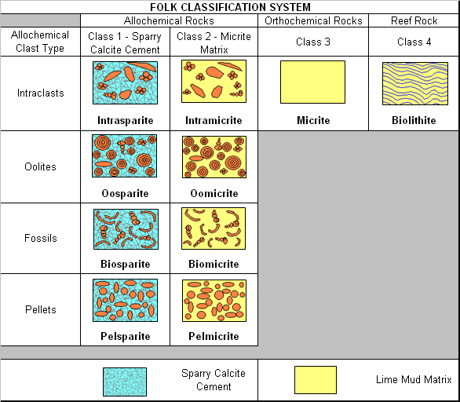

Figure 1. The Folk limestone classification is good for microscope thin section work. This classification is divided into three groups that include particles of sand size or larger, micrite, and cement. All particles are allochemical whereas the cement, known as sparry calcite, and micrite are orthochemical constituents. Four types of particles are found within the allochemical rocks – intraclasts, oolites, fossils, and pellets. Image adapted from Friedman and Sanders, 1978.

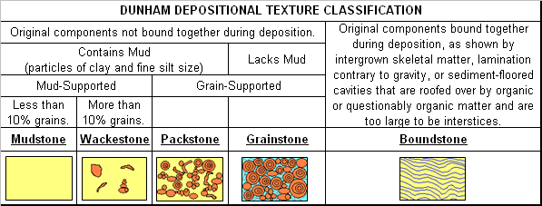

Figure 2. The Dunham limestone classification is based on texture and grain size, and is good for use in hand specimen and in outcrop. This classification is based on two groups, those whose components are bound together and those in which the original components were not bound together. The first group includes rocks such as reefs, stromatolites, and travertine. The second group includes rock consisting of coarse particles and micrite. Image adapted from Friedman and Sanders, 1978.

Table 1

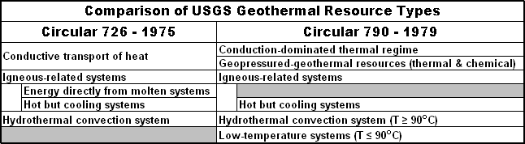

Table 2

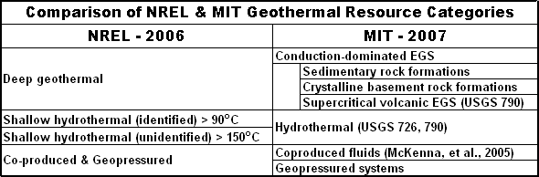

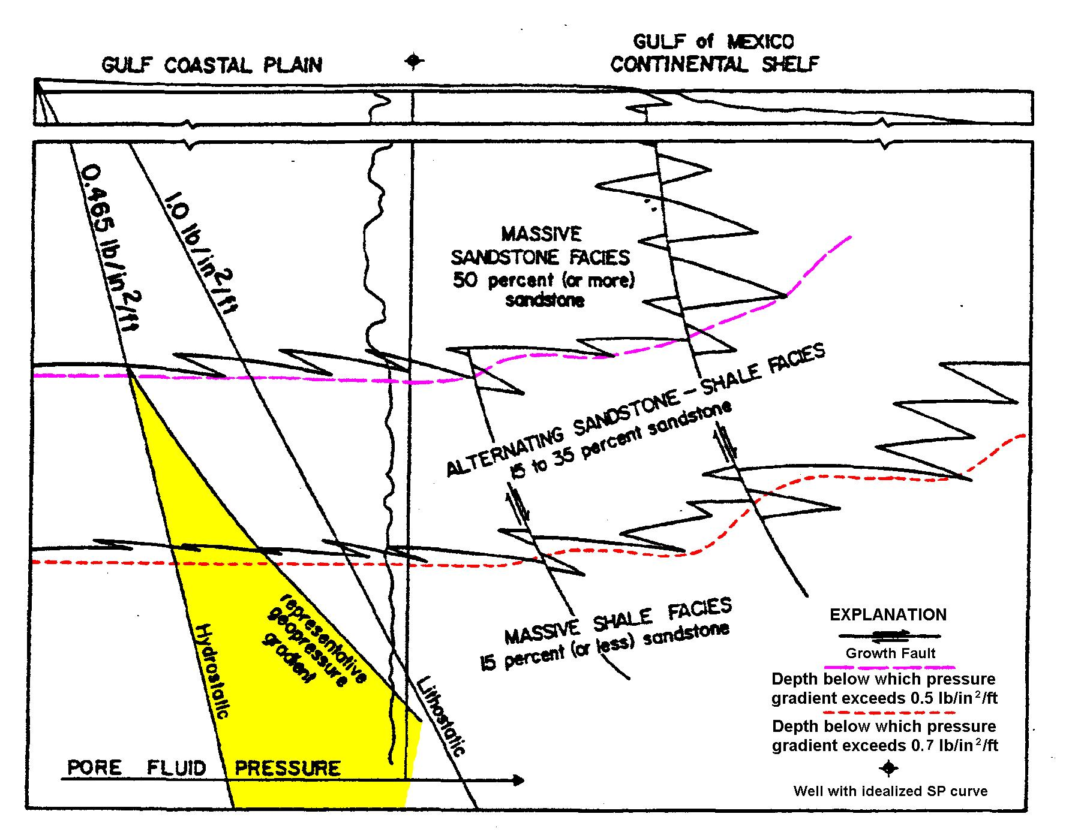
Figure 3. This image is a generalized sedimentary model taken from the Gulf of Mexico, based on percentage of sandstone and diagrammatically showing the relation of gross lithology to fluid-pressure gradient and growth. The normal hydrostatic load increases in a geopressured environment to near lithostatic conditions due to the increase in pore fluid pressure within the sandstone. Image is modified from Norwood and Holland, 1974.

Table 3

