William P. Clements

Department of History

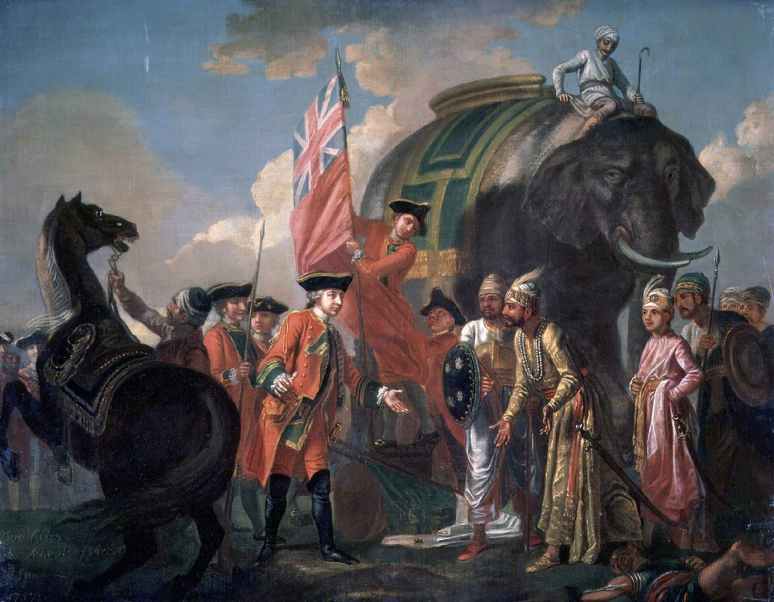

Take History, Make History

Spring 2025

**Spring 2025 History Course Schedule**

|  |  |  |  |  |  |
| --- | --- | --- | --- | --- | --- |
| Class/Sect. | Course Title | Day | Time | Instructor | Room |
| HIST 1322-001 | Intro. Topics/American History Seminar: History of Global Video Games | Tu/Th | 9:30-10:50 | Palmer, Scott | Hyer Hall 204 |
| HIST 1322-002 | Intro. Topics/American History Seminar:  Dem. Revs: US, Britain, France | MWF | 2:00-2:50 | Winnie, Laurence | Dallas Hall 357 |
| HIST 1322-003 | Intro. Topics/American History Seminar: Dem. Revs: US, Britain, France | MWF | 3:00-3:50 | Winnie, Laurence | Dallas Hall 357 |
| HIST 2306-001H | The Kids Are All Right | Tu/Th | 12:30-1:50 | DeLuzio, Crista  Levy, Bruce | Dallas Hall 116 |
| HIST 2311-001 | Out of Many: US History to1 1877 | MWF | 1:00-1:50 | Swain, Greta | Prothro Hall 100 |
| HIST 2314-701 | On the Edges of Empire | W | 6:00-8:50 | Ball-Phillips, Rachel  Foley, Neil | Fondren Science 123 |
| HIST 2315-001 | Modern China | Tu/Th | 11:00-12:20 | Keliher, Macabe | Fondren Science 155 |
| HIST 2337-001 | US Sports History | Tu/Th | 2:00-3:20 | McCrossen, Alexis | Dallas Hall 102 |
| HIST 2351-001 | Medieval World: 1095-1350 | MWF | 10:00-10:50 | Lopez, Bianca | Clements Hall 225 |
| HIST 2385-001 | Latin America in Modern Era | Tu/Th | 12:30-1:30 | Mijangos y Gonzalez, Pablo | Dallas Hall 156 |
| HIST 2392-001 | Modern Africa | MWF | 11:00-11:50 | Kelly, Jill | Dallas Hall 306 |
| HIST 3301-701C | Human Rights: America’s Dilemma | Tu | 6:30-9:20 | Halperin, Rick | Clements 120 |
| HIST 3301-702C | Human Rights: America’s Dilemma | W | 6:30-9:20 | Halperin, Rick | Clements 120 |
| HIST 3314-001 | African Americans in US, 1877-Present | Tu/Th | 9:30-10:50 | Hamilton, Kenneth | Dallas Hall 116 |
| HIST 3336-001H | United States Cultural History | Tu/Th | 11:00-12:20 | McCrossen, Alexis | Dallas Hall 106 |
| HIST 3350-001 | A History of Ancient Egypt | Tu/Th | 11:00-12:20 | Dowling, Melissa | Dallas Hall 101 |
| HIST 3359-001H | Europe Age of Reformation | MWF | 11:00-11:50 | Winnie, Laurence | Dallas Hall 152 |
| HIST 3395-001 | Problems in Asian History: Empire, Law, & Society in South Asia | MW | 3:00-4:20 | Pillai, Sarath | Fondren Science 155 |
| HIST 3395-002 | Problems in Asian History: Capitalism in South Asia | MWF | 10:00-10:50 | Pillai, Sarath | Umphrey Lee Center 242 |
| HIST 4300-001 | Junior Seminar Research & Writing Seminar: The Weimar Republic | Tu | 2:00-4:50 | Hochman, Erin | Dallas Hall 138 |
| HIST 4300-002 | Junior Seminar Research & Writing Seminar: Overcoming Apartheid | W | 2:00-4:50 | Kelly, Jill | Dallas Hall 343 |
| HIST 4390-001 | Senior Seminar:  Politics & Religion in Latin America | Tu | 3:00-5:50 | Mijangos y Gonzalez, Pablo | Dallas Hall 143 |
| HIST 4390-002 | Senior Seminar:  Enslavement in the Caribbean | Th | 2:00-4:50 | Hamilton, Kenneth | Dallas Hall 0149 |
| HIST 6302-001 | Colloquium: American History 1812-1877 | M | 2:00-4:50 | Ron, Ariel | Dallas Hall 70 |
| HIST 6306-001 | Intro to Digital Humanities | W | 2:00-4:50 | Lopez, Bianca | Annette Caldwell Simmons Hall 221 |
| HIST 6392-001 | Topics in Chinese History | Th | 2:00-4:50 | Keliher, Macabe | Dallas Hall 70 |
| HIST 6397-001 | Transnational Research: Global Transformations | Tu | 10:00-12:50 | Foley, Neil | Dallas Hall 70 |

**Front cover image: Francis Hayman, "Lord Clive meeting with Mir Jafar at the Battle of Plassey in 1757"  (1760). This battle marked the establishment of the British Empire in South Asia, or the transition of English East India Company from a trading company to rulers of India, in the second half of the eighteenth century. To learn more, sign up for Dr. Sarath Pillai’s HIST 3395-001 or HIST 3395-002.**

**Spring 2025 Faculty Contacts**

|  |  |  |
| --- | --- | --- |
| Sabri Ates 214-768-2968 | Dallas Hall 65 | [Sates@smu.edu](mailto:sates@smu.edu) |
| Rachel Ball-Phillips 214-768-3808 | Moody Hall 209 | [Rmball@smu.edu](mailto:rmball@smu.edu) |
| Katherine Carté 214-768-2977 | Dallas Hall 356 | [K](mailto:kengel@smu.edu)[engel@smu.edu](mailto:engel@smu.edu) |
| Crista J. DeLuzio 214-768-3748 | Dallas Hall 51 | [Cdeluzio@smu.edu](mailto:cdeluzio@smu.edu) |
| Melissa Dowling 214-768-2976 | Dallas Hall 77 | [Mdowling@smu.edu](mailto:mdowling@smu.edu) |
| David Doyle 214-768-2813 | Clements Hall G01B | [Ddoyle@smu.edu](mailto:ddoyle@smu.edu) |
| Johan Elverskog 214-768-4127 | Hyer Hall 300B | [Johan@smu.edu](mailto:johan@smu.edu) |
| Jeffrey A. Engel 214-768-3973 | Dallas Hall 318 | [Jaengel@smu.edu](mailto:jaengel@smu.edu) |
| Neil Foley 214-768-3753 | Dallas Hall 302 | [Foleyn@smu.edu](mailto:foleyn@smu.edu) |
| Andrew R. Graybill 214-768-2709 | Dallas Hall 338 | [Agraybill@smu.edu](mailto:agraybill@smu.edu) |
| Brian Franklin 214-768-3782 | Dallas Hall 227 | Brfranklin@smu.edu |
| Rick Halperin 214-768-3284 | Clements Hall 109 | [R](mailto:rhalperi@smu.edu)[halperi@smu.edu](mailto:halperi@smu.edu) |
| Kenneth Hamilton 214-768-2889 | Dallas Hall 221 | [Km](mailto:kmarvin@smu.edu)[arvin@smu.edu](mailto:arvin@smu.edu) |
| Erin R. Hochman 214-768-3971 | Dallas Hall 64 | [Ehochman@smu.edu](mailto:ehochman@smu.edu) |
| Macabe Keliher 214-768-2998 | Dallas Hall 59 | [Macabe@smu.edu](mailto:macabe@smu.edu) |
| Jill E. Kelly 214-768-2971 | Dallas Hall 55 | [Jillk@smu.edu](mailto:jillk@smu.edu) |
| Thomas J. Knock 214-768-2972 | Dallas Hall 333 | [T](mailto:tknock@smu.edu)[knock@smu.edu](mailto:knock@smu.edu) |
| Bianca Lopez 214-768-3683 | Dallas Hall 63 | [B](mailto:biancal@smu.edu)[iancal@smu.edu](mailto:iancal@smu.edu) |
| Alexis M. McCrossen 214-768-3676 | Dallas Hall 352 | [Amcross@smu.edu](mailto:amcross@smu.edu) |
| Pablo Mijangos 214-768-3746 | Dallas Hall 337 | Pmijangosygonzalez@smu.edu |
| Brandon Miller 214-768-4543 | Clements Hall G02AD | [Bgmiller@smu.edu](mailto:bgmiller@smu.edu) |
| Scott Palmer 214-768-2000 | Dallas Hall 67 | swpalmer@smu.edu |
| Sirath Pillai 214-768-3744 | Dallas Hall 60 | sspillai@smu.edu |
| Ariel Ron 214-768-4043 | Dallas Hall 56 | [Aron@smu.edu](mailto:aron@smu.edu) |
| Greta Swain 214-768-6960 | Dallas Hall 58D | Gswain@smu.edu |
| Kathleen A. Wellman 214-768-2970 | Dallas Hall 328 | [Kwellman@smu.edu](mailto:kwellman@smu.edu) |
| Laurence H. Winnie 214-768-2980 | Dallas Hall 58B | [Lwinnie@smu.edu](mailto:lwinnie@smu.edu) |

**Undergraduate Program**

**The History Major**

Within the minimum 122-semester-hour degree, 33 semester hours in history are required for the History major. Students must take at least six semester hours in each of the following three areas:

(1) United States history, (2) European history, and (3) African, Asian, Latin American, or Middle Eastern history. At least eighteen semester hours in courses at the 3000-4000 level are required for all majors, which includes two required courses, HIST 4300 and HIST 4390. The eighteen semester hours of advanced courses must be taken in residence. History majors must earn a 2.00 minimum GPA in their History coursework. Courses for the major may not be taken pass/fail. All advanced courses taken for the major must be passed with a grade of C minus or better. Those who plan to continue with advanced historical study after graduation are encouraged to take an appropriate foreign language.

History 4300, the Junior Seminar in Research and Writing, is required. It counts as three hours of the eighteen advanced hours required for the major but cannot be counted toward area distribution requirements for the major. HIST 4390, the Senior Seminar counts towards area distribution requirement as well as toward advanced credit requirement. **NOTE**: Majors are required to take the Junior Seminar during their junior year—not before or after that time. Any exception to this rule must be cleared by the Director of Undergraduate Studies and the Department Chairperson.

**The History Minor**

Students with a general interest in history may pursue a minor by taking fifteen semester hours of departmental coursework. Nine semester hours must be taken at the 3000-4000 level. Students may transfer in no more than two of the five courses required for the minor. Only one of the three required advanced courses may be transferred in. Courses for the minor may not be taken pass/fail. All advanced courses taken for the minor must be passed with a grade of C minus or better. Students intending to take a minor in the department should design a program of study in consultation with the Director of Undergraduate Studies.

**Internship Program**

To promote learning based on practical experience and to expose students to some of the careers that can be pursued with a History major, the History Department offers the opportunity to earn up to three credit hours for an approved internship (HIST 4185, HIST 4285, HIST 4385). For details about the program, contact the department at [hist@smu.edu](mailto:hist@smu.edu).

**Departmental Distinction**

History majors with sufficiently high standing may graduate with honors in history by applying for the degree "with departmental distinction." Eligible students--those who have completed 21 hours of History credit, including the Junior Seminar— with a 3.7 History GPA and overall 3.5 GPA—will be invited by the Department Chair to apply. Candidates for distinction will pursue an individual research project under the direction of a particular professor (while enrolled in HIST 4375). Such a major research project will develop out of the HIST 4390, the Senior Seminar, or HIST 4300, the Junior Seminar. The research project will be presented as a thesis before the end of the semester. The successful honors candidate must pass an oral examination on the thesis before a committee of three history faculty and receive at least an A minus on the work.

**Academic Prizes for Undergraduates**

**The Jacobus Junior Paper Prize in History**

Students enrolled in a HIST 4300 Junior Seminar in the Spring and Fall semesters are eligible for the Jacobus Junior Paper Prize in History, which will be awarded near the end of each Spring semester. The award, which has been given since 1993, was renamed the Henry S. Jacobus Junior Paper Prize in History in 1998 to honor a long-time friend of SMU and history enthusiast and benefactor, Henry S. Jacobus, Jr. After retiring as a respected member of the Dallas business community, Mr. Jacobus began auditing History courses at SMU and became a good friend to professors and students alike. We wish to honor Mr. Jacobus, who died in 1998, by identifying his name with this very important area of scholarly endeavor and achievement.

The prize recipient will be selected from among junior research papers completed during the Spring and Fall semesters. Nominations are made by professors who teach the Junior Seminars, and a special committee of SMU history faculty judges. For further details, email the Director of Undergraduate Studies, Professor Macabe Keliher, at [macabe@smu.edu](mailto:macabe@smu.edu).

**Herbert Pickens Gambrell Award for Outstanding Academic Achievement**

This award is given in honor of the late Professor and historian Herbert Pickens Gambrell (SMU class of 1921), who was the founder of SMU Press, the first managing editor of the *Southwest Review*, and a leader in various organizations, including the Dallas Historical Society, the Texas Historical Association, and the Texas Institute of Letters.

**The Stanton Sharp Award for Outstanding Service and Academic Achievement**

This award is named in honor of Stanton Sharp, the son of our exceedingly generous long-time benefactor, the late Ruth Sharp Altshuler, the former SMU Board of Trustees chairperson. The Sharp Fund has also enhanced faculty research and teaching in the History Department.

**Undergraduate Courses**

**Introductory Topics in European History:**

**History of Global Video Games**

Fulfills: CC: Historical Contexts, Writing

UC 2016 Breadth: Historical Contexts

**HIST 1322-001**

Tuesday/Thursday, 9:30am-10:50am, 204 Hyer Hall

Professor Scott Palmer

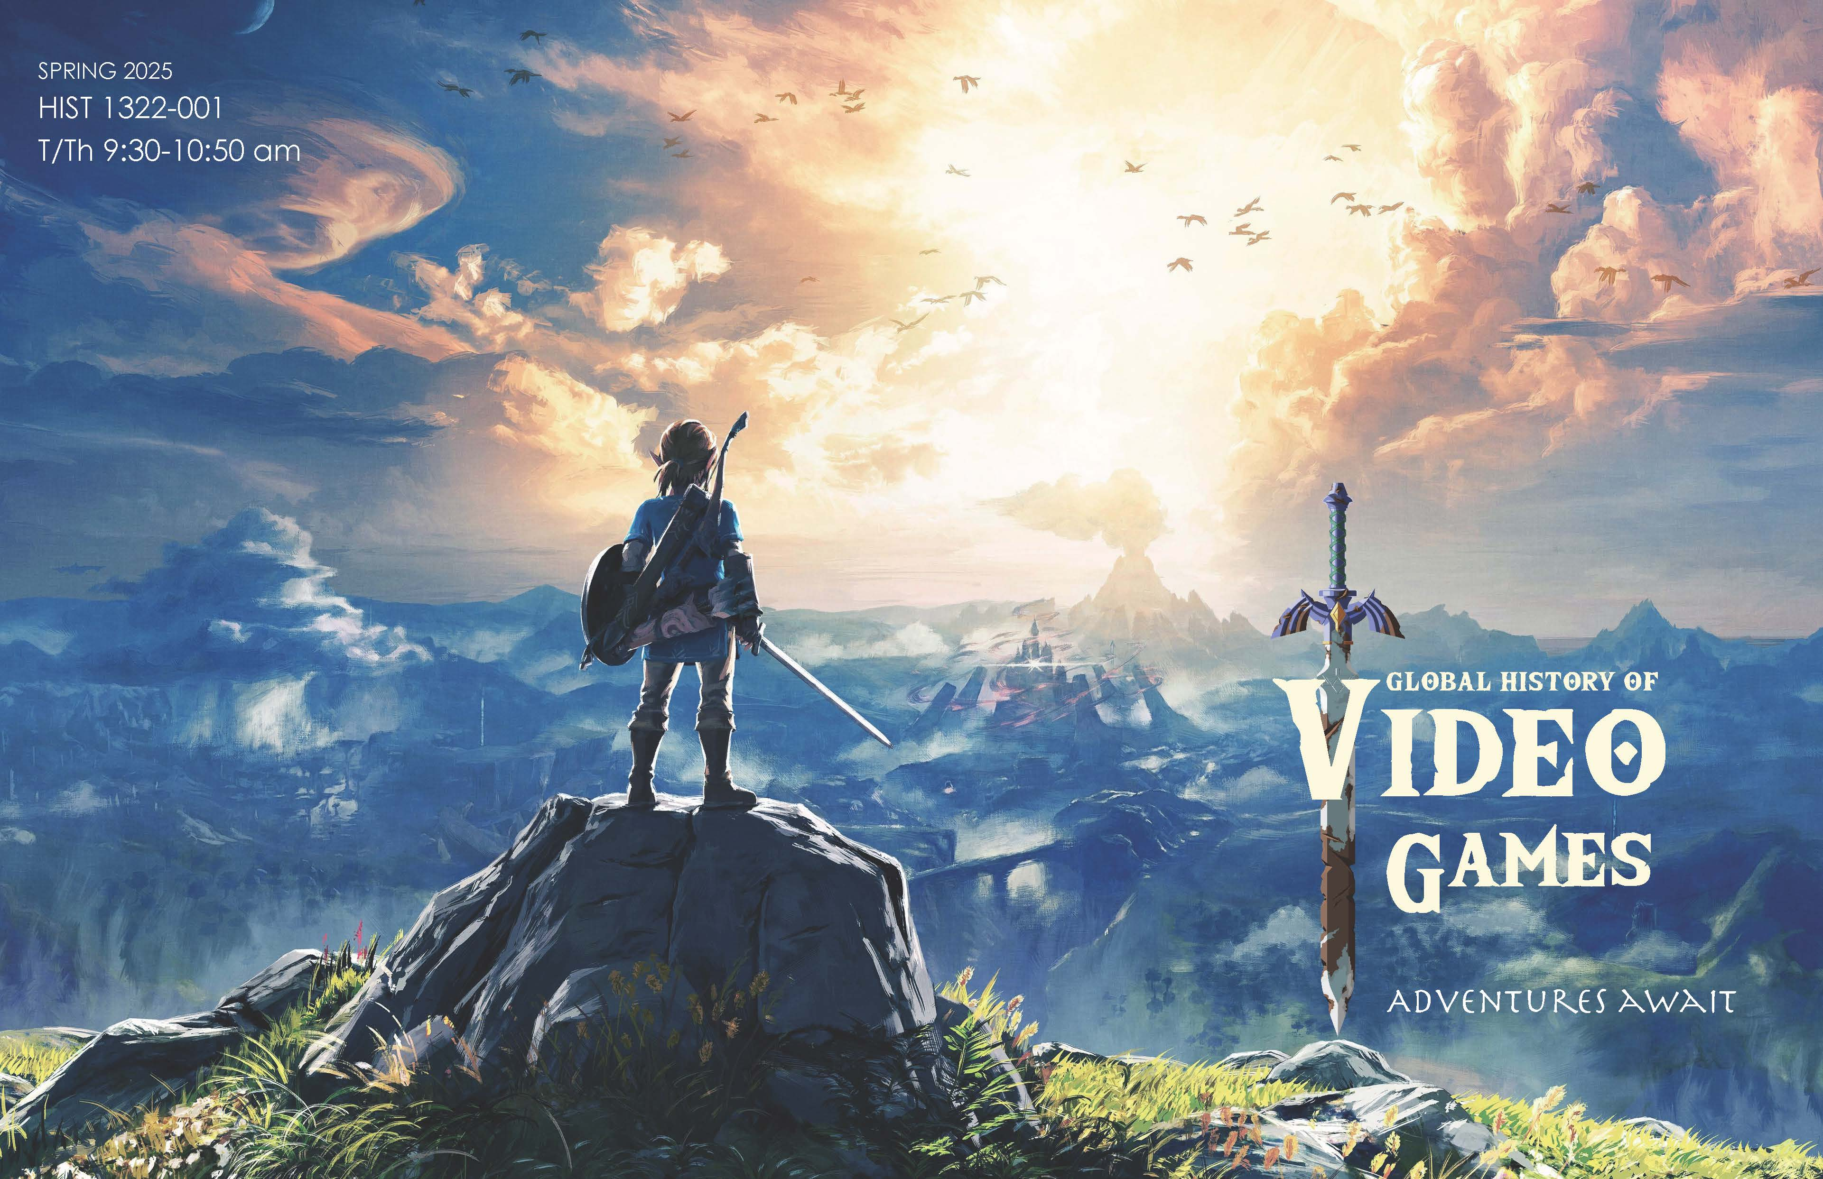

This open-world edutainment adventure explores the history of the twentieth century’s most popular invention: electronic (video, computer, and console) games. Founded upon technologies built by America’s Cold War military-industrial-educational complex, brought to life by subterranean bands of fun-loving “hackers,” then exploited (and nearly killed) by corporate business interests, video games have evolved from a technological curiosity enjoyed by a few into a multi-billion-dollar global industry embraced by the masses. Along the way, they have shaped (and been shaped by) prevailing cultural, social, economic and political forces.

During the semester students will examine a wide range of topics including: the technological origins of computer gaming; the birth of “hackers” and “hacker ethics;” video game economics and (big) business; the impact of video games on popular culture; gaming genres, design, and aesthetics; on-line communities and gamer identities; the practical applications of game simulations; the rise of eSports; and the possible futures of games to come (to name but a few).

In addition to providing students with a platform for honing skills at research, analysis, and writing, this course aims to demonstrate that as with airplanes, automobiles, rockets, and other technological gadgets, the historically grounded study of video games enables us to develop a greater appreciation of the fruits of human ingenuity and a deeper understanding of our shared, human condition.

**Readings include**: 1) *America’s Digital Army: Games at Work and War,* Allen, Robert; 2) *Intellivision: How a Video Game System Battled Atari and Almost Bankrupted Barbie*, Boellstorff, Tom and Soderma, Braxton; 3) *Codename Revolution: The Nintendo Wii Platform,* Jones, Steven E. and Thiruvathukal, George K.; 4) *Too Much Fun: The Five Lives of the Commodore 64 Computer, Juul, Jesper.*

**Introductory Topics in European History:**

**Democratic Revolutions: US, Britain, France**

Fulfills: CC: Historical Contexts, Writing

UC 2016 Breadth: Historical Contexts

HIST 1322-002

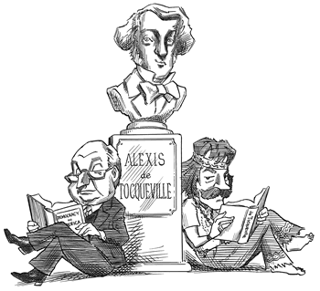Monday/Wednesday/Friday, 2:00pm-2:50pm, 357 Dallas Hall

HIST 1322-003

Monday/Wednesday/Friday, 3:00pm – 3:50pm, 357 Dallas Hall

Professor Laurence Winnie

This course explores the complex vision of Alexis de Tocqueville (1805-59), author of *Democracy in America* (1835, 1840), about the democratic revolutions that were transforming the world in the nineteenth century. Like many courses on Tocqueville’s thought, it will engage with the ideas about democracy he developed in his famous book on America.  Unlike other courses on Tocqueville, it will focus on his observations on these democratic revolutions in four countries: America, England, Ireland, and France. This course will be valuable to students interested in American politics, American history, British and French history, and politics and culture.

**Readings include**:Alexis de Tocqueville, *Democracy in America*; *Recollections*; *The Ancient Regime and the Revolution;* and Seymour Drescher, *Tocqueville and England*.

**The Kids Are Alright**

Fulfills: CC General Education, Breadth; Historical Contexts,

CC Graduation Requirements, Proficiencies & Experiences: Human Diversity; Writing

**HIST 2306-001H**

Tuesday/Thursday 12:30pm-1:50pm, 116 Dallas Hall

Team Instruction with Professors Crista DeLuzio (History) and Professor Bruce Levy (English)

*The Kids Are Alright* examines key issues associated with American youth from historical, literary, and other disciplinary perspectives. The course explores childhood and adolescence as flexible social constructs that reflect – and respond to – larger forces of historical change. Among the questions we will seek to answer are these: At any given historical moment, what were the prevailing expectations for girls and boys growing up, and how did those expectations resonate with broader cultural hopes, longings, and anxieties? How were young people shaped by prevailing expectations for growing up, and how did they play a role in shaping those expectations and the wider society in return? What has changed and what has stayed the same regarding how children were viewed and treated, how they lived their lives over the course of U.S. history, and with what consequences for children’s lives in the present? We will consider children and adolescents in various contexts: in the family, at school, at work, and at play, as well as examine their roles and influence as objects of reform, consumers, social activists, and cultural icons. Throughout the course, we will pay close attention to the multiple paths of growing up in the United States, especially to the ways in which the categories of gender, race, ethnicity, and social class have shaped experiences and representations of childhood and adolescence.

**Readings include:**1) Steven Mintz, *Huck’s Raft: A History of American Childhood*; 2) Horatio Alger, *Ragged Dick*; 3) Lynda Barry, *One Hundred Demons*; 4) Stephen Crane, *Maggie a Girl of the Streets*; 5) Frederick Douglass, *Narrative of the Life of Frederick Douglass*; 6) James T. Farrell, *Young Lonigan*; 7) Hannah Foster, *The Coquette*; 8) Paule Marshall, *Brown Girl, Brownstones*; 9) J.D. Salinger, *The Catcher in the Rye*;  10) Henry James, *Daisy Miller*; 11) Other primary sources and excerpts from historical monographs, accessible via the Web and on Canvas

**Out of Many: US History to 1877**

Fulfills: UC2016: Breadth/Historical Contexts;

UC2016 Breadth/Individuals, Institutions, Cultures

**HIST 2311-001**

Monday/Wednesday/Friday, 1:00pm-1:50pm, 100 Prothro Hall

Professor Greta Swain

This course offers a survey of social, political, economic and cultural transformations in American history, from European colonization through Reconstruction. Central themes include interactions between people across nation, race, gender, and class lines; establishment and growth of political systems; the development of slavery and race; social movements; sectional tensions; and vast changes in transportation and the economy. Although primarily focused on the geographic region which became the modern-day United States, the course also considers the U.S. as part of a global system of exchange. This helps students see how American events are connected to broader international developments. In addition to studying historical content, this course will introduce students to the methods used in the discipline of history. Students will learn how to analyze historical primary sources, read critically, contextualize information, make inferences, consider alternative perspectives, and construct arguments. Finally, this course will help students draw lessons from the past which inform contemporary issues and decision making for the future.

**Readings include: 1**) Peter Charles Hoffer, *Cry Liberty: The Great Stono River Slave Rebellion of 1739*;2)*American Yawp* (online); 3) Select episodes of *Ben Franklin’s World* podcast; 4) Various scholarly articles and primary sources (online)

**On the Edges of Empire**

**India and Mexico/American Southwest**

Fulfills: CC: Historical Contexts

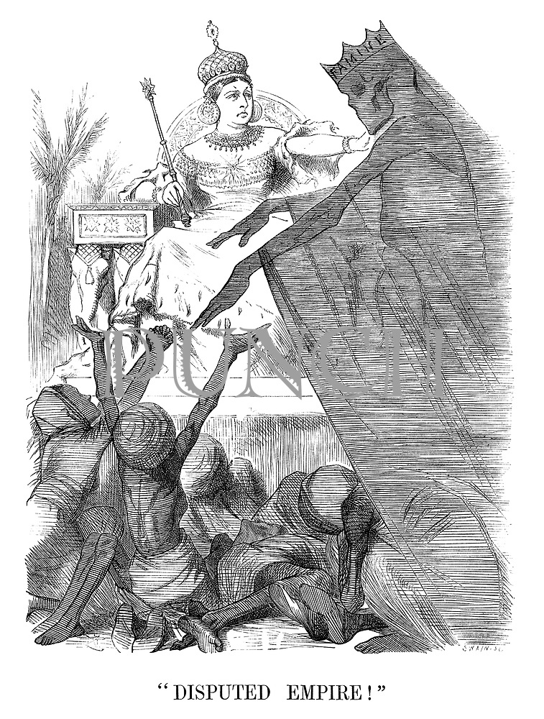**HIST 2314-701**

Wednesday, 6:00pm-8:50pm, 123 Fondren Science

Professor Neil Foley and Dr. Rachel Ball-Phillips

Spanning the globe from the Americas to South Asia, this interdisciplinary course will examine the peripheries of empires. Rather than looking at the history of empires from the view of European powers (England and Spain), this course takes us to the places that were conquered in order to gain a broader understanding of how empire and colonialism worked, or failed to work, and ultimately what led these “edges of empires” to decolonize and gain independence (India and Mexico) – and, in the case of the American Southwest, become incorporated into another empire: the United States. This course provides an in-depth interdisciplinary study of the British colonization of India and the expansion of New Spain into the northern borderlands of present-day Mexico and the American Southwest. Using film/visual culture in addition to historical texts, we will explore common themes of colonial ideologies, class/caste and gender formations, legal and economic systems, emerging regional and national identities, religious cultures, and other topics from the eighteenth century to the present.

**Readings include**: 1)Selected chapters from Edward Said, *Orientalism*; 2) Nora MacQueen, *Colonialism*; 3) John Chasteen, *Born in Blood and Fire*; 4) Matthew Restall, *Seven Myths of the Spanish Conquest*; 5) Prasannan Parthasarathi, *Why Europe Grew Rich and Asia Did Not*; 6) Shashi Tharoor, *Inglorious Empire: What the British Did to India*; 7) Neil Foley, *Mexicans in the Making of America*; Rachel Ball-Phillips, “Digital Archives: Teaching Indian Colonial History through Photographs” in *Education About Asia*; 7) Douglas Peers and Nandini Gooptu, *India and the British Empire*; 8) Thomas Metcalf, *Ideologies of the Raj*; 9) Maria Elena Martinez, “Black Blood of New Spain: Limpieza de Sangre, Racial Violence and Gendered Power in Early Colonial Mexico,” in *William and Mary Quarterly*; 10) Sumathi Ramaswamy, *The Visual Culture Reader*; 11) David Weber, *Myth and the History of the Hispanic Southwest.*

**Modern China**

Fulfills CC General Education, Breadth: Historical Contexts

UC2016: Breadth/Historical Contexts

HIST 2315-001

Tuesday/Thursday, 11:00am-12:20pm, 155 Fondren Science

Professor Macabe Keliher

Explores the social, political, and economic organization of life in modern China. Taking as its focus the changes and transformations in the eighteenth through twentieth centuries, students will engage key issues including the Qing conquest, European imperialism, economic modernization, women’s rights, and the rise of communism. No prior knowledge of Chinese history is assumed or required.

**Readings include:** Elliott, *Emperor Qianlong*; Kuhn, *Origins of the Modern Chinese State*, Snow, *Red Star over China*.

**US Sports History**

Fulfills CC General Education, Breadth: Historical Contexts; CC Human Diversity: UC 2016 Historical Contexts; UC 2016 Human Diversity

**HIST 2337-001**

Tuesday/Thursday, 2:00pm – 3:20pm, 102 Dallas Hall

Professor Alexis McCrossen

This course presents an overview of the development of amateur and professional athletics during the nineteenth and twentieth centuries in the United States. It considers the social, cultural, and business history of sports in the United States. Class meetings will include sports history lectures (often illustrated), the screening of sports documentaries, guided discussions, and student presentations.

**Readings include**: Richard Davies, *Sports in American Life (3rd edition)*.

**Medieval World: 1095 to 1350**

Fulfills CC Historical Contexts

UC2016: Breadth/Historical Contexts

**HIST 2351-001**

Monday/Wednesday/Friday, 10:00am-10:50am, 225 Clements Hall

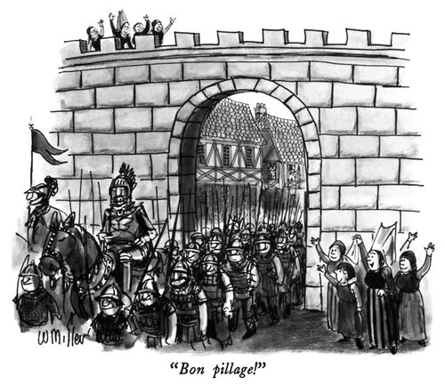Professor Bianca Lopez

This course considers the latter half of medieval European history from the First Crusade (1095) to the aftermath of the Black Death (c.1350), with particular emphasis on the emergence of Western European identity. In investigating the later Middle Ages, we will consider how institutions arose and developed, including Christianity’s spread and the return of centralized kingdoms. Religious persecution, economic revival, and environmental crises define these centuries, and we will turn to those themes throughout this course. Required readings will include a textbook and sourcebook of documents, including law codes, saints’ lives, the deeds of kings, and anti-heretical writings, all of which reflect the diversity of the medieval world.

**Readings include**: 1) Patrick Geary, ed., *Readings in Medieval History. Vol. 1. Fifth Edition* (Toronto: University of Toronto Press, 2015); 2) Barbara H. Rosenwein, *A Short History of the Middle Ages. Vol. I. Fourth Edition* (Toronto: University of Toronto Press, 2014).

**Latin America in Modern Era**

Fulfills: UC 2016 Historical Contexts; CC Historical Contexts

HIST 2385-001

Tuesday/Thursday, 12:30pm-1:50pm, 156 Dallas Hall

Professor Pablo Mijangos y Gonzalez

This course examines the history of Latin America from the crisis of the Iberian empires to the present. Since “Latin America” refers to a wide set of different countries and peoples, each with a very complex history, we will focus on the historical developments and problems shared by the entire region. Particular emphasis will be placed on the processes of nation-building and state formation, the interdependence of local economies with global markets, the effects of modernization in highly unequal and diverse societies, the different responses to the pervasive influence and military interventions of the U.S., the dialectical relationship between revolutions and dictatorship, and the challenges for consolidating lasting democratic regimes and the rule of law.

**Readings include:** 1) Will Fowler, *Latin America Since 1780* (3rd edition); 2) Hilda Sabato, *Republics of the New World*; 3) Alan Knight, *The Mexican Revolution: A Very Short Introduction*; 4) Vanni Pettinà, *A Compact History of Latin America’s Cold War*, and other selected readings.

**Modern Africa**

Fulfills: UC 2016 Historical Contexts; CC - Historical Contexts;

CC - Global Perspectives; CC - Human Diversity

**HIST 2392-001**

Monday/Wednesday/Friday, 11:00am-11:50am, 306 Dallas Hall

Professor Jill Kelly

Although colonialism and the Cold War constitute two major epochs in Modern African history, neither lasted for more than one hundred years in most parts of Africa. Yet as brief as they were, colonialism and the politics of the Cold War left lasting legacies on the continent. This course will be divided roughly into three units in order to examine colonialism in Africa, the emergence of independent African nation-states in the midst of the Cold War, and the effects of these on contemporary Africa. Because the experiences of Africans are so diverse, for each unit we will draw on case studies from North, West, East, and Southern Africa to highlight such themes as: commerce, colonialism, race and racism, gender, religion, resistance, sports, music, and nationalism. We will read African accounts, including fiction, autobiographies, and political speeches, in order to better understand and appreciate African cultures and ways of thinking, as well as secondary sources.

**Readings include:** 1) Solomon Plaatje, *Mhudi*; 2) Bakary Diallo and Lamine Senghor, *White War, Black Soldiers: Two African Accounts of World War I*; 3) Ngugi wa Thiongo, *Dreams in a Time of War*;4) Tabitha Kanogo, *Wangari Maathai;* 5) Wayetu Moore, *The Dragons, the Giant, and the Women;* 6) Other online readings.

**Human Rights: America's Dilemma**

Fulfills: CC General Education, Breadth: Historical Contexts

CC Graduation Requirements, Proficiencies & Experiences: Community Engagement; Writing

UC2016: Breadth/ Historical Contexts

UC2016: Proficiencies & Experiences/Writing/Community Engagement

**HIST 3301-701C (Co-listed with HRTS 3301-701C) HIST 3301-702C (Co-listed with HRTS 3301-702C)**

Tuesday 6:30pm-9:20pm, 120 Clements Hall Wednesday 6:30pm-9:20pm, 120 Clements Hall

Professor Rick Halperin Professor Rick Halperin

The study of human rights requires a sense of history and moral courage, for no nation or society has been innocent of human rights abuses. This course will examine certain violations of human rights within their historical context. It will also focus on America's human rights record, with regard to its own policies and its relationship to human rights violations in other countries. Attention will also be given to the evolution of civil and human rights as entities within global political thought and practice. Students will be encouraged to rely on reasonable evidence and critical thinking when studying these historical controversies, rather than on biased accounts or emotional arguments. From torture to terrorism and from slavery to genocide, students will discuss the current status of human rights in the world today.

**Readings include**: 1) Rebecca Cook, *Human Rights for Women*; 2) John T. Parry, *Understanding Torture: Law, Violence, and Political Identity;* 3) Henry Friedlander, *Origins of Nazi Genocide*; 4) Ben Kiernan, *Genocide & Resistance in Southeast Asia: Documentation, Denial, and Justice in Cambodia and East Timor*; 5) Samantha Power, *A Problem from Hell: America and Age of Genocide.*

**African Americans in the US, 1877-Present**

Fulfills: CC General Education, Breadth: Historical Contexts

CC Graduation Requirements, Proficiencies & Experiences: Human Diversity

UC2016: Breadth/ Historical Contexts

UC2016: Proficiencies & Experiences/Human Diversity

**HIST 3314-001**

Tuesday/Thursday, 9:30am-10:50am, 116 Dallas Hall

Professor Kenneth Hamilton

This course studies the experiences of African Americans in the United States from 1877 to the present. In conceptualizing African-American history since 1877, particular attention will be given to the promise and disillusion of the post-Civil War period, African-American leadership ideologies, the influence of mass migrations, the impact of the Great Depression and two world wars on African-American life, the urban African- American movement, the quest for equality in the 1950's, and culminating with the Civil Rights Movement in the 1960's and the flowering of African-American culture and nationalism.

**Readings include**: 1) Deborah Gray White*, Freedom on My Mind*; 2) Mark R. Schneider, *African Americans in the Jazz Age.*

**United States Cultural History**

Fulfills: CC General Education, Breadth: Historical Contexts

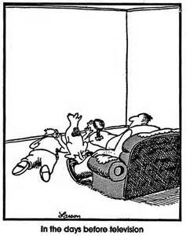**HIST 3336-001H**

Tuesday/Thursday, 11:00am-12:20am, 106 Dallas Hall

Professor Alexis McCrossen

This course presents an overview of the development of popular culture in the United States *before* the television age.  It introduces students to significant cultural brokers, institutions, forms, and events.  The aim of the class is to introduce students to major themes and moments in the history of culture in the United States.

**Readings include**: 1) LeRoy Ashby *With Amusement for All*; 2) Neil Harris *Humbug: The Art of P.T. Barnum*

**A History of Ancient Egypt**

Fulfills: CC Breadth: Historical Contexts

**HIST 3350-001**

Tuesday/Thursday, 11:00am-12:20pm, 101 Dallas Hall

Professor Melissa Barden Dowling

This class is a history of ancient Egyptian civilization from the construction of the pyramids to conquest by the Romans, explored through Egyptian literature, archaeology, and artifacts. Fieldtrips to the Dallas Museum of Art and our own antiquities collection at Bridwell Library will be included.

**Readings include**: 1) William Kelly Simpson, *The Literature of Ancient Egypt*; 2) Joyce Tyldesley, *Daughters of Isis: Women of Ancient Egypt*; 3) Gay Robins, *The Art of Ancient Egypt*; 4) Marc Van De Mieroop, A History of Ancient Egypt and other readings on ancient Egyptian archaeology, history and culture.

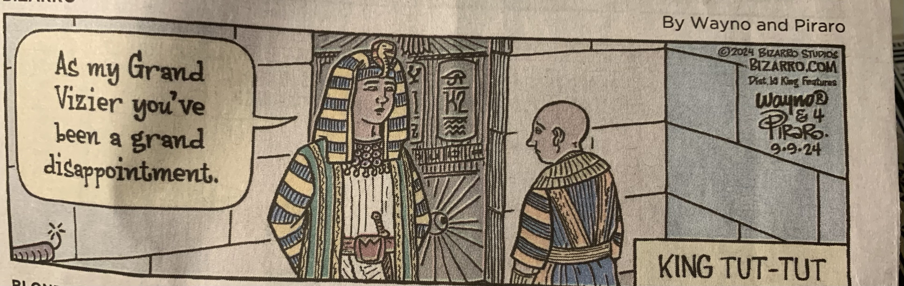

**Europe in the Age of the Reformation**

      UC2016 and CC: Historical Contexts. UC2016: Depth/Humanities & Fine Arts

UC2016 and CC: Proficiencies & Experiences/Writing

**HIST 3359-001**

Monday/Wednesday/Friday, 11:00am-11:50am, 152 Dallas Hall

Professor Laurence Winnie

This class includes the political, economic, religious and cultural history of Europe, including the impact of the Protestant and Catholic reform movements.

**Readings include**: 1) Jean Calvin*, Institutes,* and *Reply to Sadoleto;* 2.) Desiderius Erasmus*, On the Free Will; 3.) Documents from the English Reformation and the Dissolution of the Monasteries; 4.)*Bartolome de Las Casas*, In Defense of the Indians; 5.)*Carter Lindberg*, The European Reformations;* 6.) Martin Luther*, On the Enslaved Will.*

**Problems in Asian History: Empire, Law, and Society in South Asia**

**Fulfills**: UC 2016 and CC Human Contexts; Global Perspectives,

Human Diversity

**HIST 3395-001**

Monday/Wednesday, 3:00pm-4:20pm, 155 Fondren Science Building

Professor Sarath Pillai

Throughout history law was instrumentalized by politicians, policy makers, lawyers, and the common people for various social and political projects. This was true of empires as much as the nation-states we live in today. This course will focus on South Asia, a part of the British Empire until 1947 and a classic region for examining the relationship between law and society. The British radically restructured Indians’ relationship with the law and justified colonial rule based on Civilizing Mission and the Rule of Law. They drafted new laws that sought to control both the private and public lives of Indians. Despite India’s independence in 1947 and make-over as the world’s largest democracy, many of these colonial laws continued to be in existence. This course will start with a discussion of the centrality of law and legality to empire and colonialism and end with how law has moved to the center of disputes between Hindus and Muslims in South Asia today. Some of the topics that the course will cover include, socio-religious reforms in colonial India (attempts to regulate marriage, female infanticide, and widow burning); formation of social categories (like depressed classes and minorities) and the politics around them; caste system; the Rule of Law; Indian nationalist thought and the new Indian Constitution; minority rights; secularism; and the rise of Hindu majoritarian politics. This course, though focused on the British Empire and South Asia, will take occasional glances at the US. Course readings will include secondary and primary materials and media resources. No prior knowledge of South Asian, British colonial or legal history required.

**Readings Include**: 1) Kitty Calavita, *Invitation to Law and Society*; 2) Marc Galanter, *Law and Society in Modern India*; 3) Bernard Cohn, *Colonialism and its Forms of Knowledge*; 4) Rohit De, *A People’s Constitution*; 5) Selected writings of Jawaharlal Nehru and B. R. Ambedkar; 6) Other articles, book chapters, archival materials and movies.

**Problems in Asian History: Capitalism in South Asia**

Fulfills: UC 2016 Human Contexts; Common Curriculum Global Perspectives, Human Diversity,

Historical Contexts

**HIST 3395-002**

Monday/Wednesday/Friday, 10:00am-10:50am, 242 Umphrey Lee

Professor Sarath Pillai

Today, India is one of the top five economies in the world and has the third largest collection of billionaires. But its economic and political rise is recent. India (and the region called South Asia) attained independence from centuries of British colonial rule only in 1947. The colonial rule fundamentally transformed the Indian economy; while it led to some technological advances like the introduction of railways and telegraphs, the colonial rule impoverished the economy. This course engages with the relationship between colonialism and capitalism on the one hand and democracy and capitalism on the other to see how the social, cultural, economic, and political features of the Indian society persisted and transformed under both colonial and post-colonial (after 1947) regimes from the eighteenth century through the present. The course begins by examining what is capitalism and the churnings in the Indian economy in the 18th century in the wake of the decline of the Mughal Empire and the coming of European colonial powers and moves through themes like the commercialization of the economy, the Indian village system, land revenue system and the British attempts to introduce capitalist relations in India, industrialization and deindustrialization, the theory of drain of wealth and the rise of Indian nationalism, rise of Indian industrialists and corporations, the ideal of “mixed economy,” India’s tryst with socialism and Five Year Planning, liberalization and privatization of the Indian economy in the 1990s, and most recently the rise of global billionaires in South Asia. No prior exposure to South Asian, British colonial, or economic history is required. Course readings will include both primary and secondary texts, and media resources.

**Readings Include**: 1) B. R. Tomlinson, *The Economy of Modern India*; 2) Mircea Raianu, *Tata*; 3) Aditya Balasubramanian, *Toward a Free Economy*; 4) Mahatma Gandhi, *Hind Swaraj*.

**Junior Seminar: Research and Writing:**

**The Weimar Republic**

Fulfills: CC General Education, Breadth: Historical Contexts

CC Graduation Requirements, Proficiencies & Experiences: Writing in the Major, Oral Communication

UC 2016: Information Literacy/Oral Communication/Writing

UC2016: Depth: History, Social and Behavioral Sciences

**HIST 4300- 001**

Tuesday, 2:00pm – 4:50pm, 138 Dallas Hall

#### Professor Erin Hochman

The Weimar Republic emerged following a destructive war and the collapse of Imperial Germany. Its founders had to contend with bitterness about defeat in the First World War, hatred of the Treaty of Versailles, political violence, and economic turmoil. Yet its inauspicious beginnings did not doom Germany’s first experiment with democracy to failure or make the rise of the Nazis inevitable. As we will see, the Weimar Republic had enormous potential. The republic not only had one of the most democratic and progressive constitutions in the world at that time, but also provided the space for Germans to experiment with the arts, experience sexual liberation, and adopt innovative technologies. While numerous Germans embraced these political, cultural, and social transformations, there was a backlash against them as well. Conservatives felt threatened by these upheavals and wished for a restoration of traditional values. New right-wing groups, such as the Nazis, rejected these progressive developments, but saw the postwar turmoil as an opportunity to create an entirely new political system based on a dictator and racist thinking. On the far left, communists also scorned the new postwar order, arguing that the revolution after the war had not gone far enough. Exploring these tensions and extremes, students will write a 25-page research paper on a topic of their own choosing related to the Weimar era.

**Junior Seminar: Research and Writing:**

**Overcoming Apartheid**

Fulfills: CC General Education, Breadth: Historical Contexts

CC Graduation Requirements, Proficiencies & Experiences: Writing in the Major, Oral Communication

UC 2016: Information Literacy/Oral Communication/Writing

UC2016: Depth: History, Social and Behavioral Sciences

**HIST 4300- 002**

Wednesday, 2:00pm – 4:50pm, 343 Dallas Hall

Professor Jill Kelly

South Africa’s transition from apartheid to democracy is often heralded as nothing short of a miracle. But the 1994 elections were the product of a century-long quest for equal rights in the country. This seminar will explore the history of the 20th century liberation struggle in South Africa. Each student will develop a research and writing project within the field of twentieth-century South African history using extensive primary and secondary source material in order to make an original contribution to the scholarship. Initial readings and class discussions will provide you with the background and inspiration to begin your work.

**Readings include:** 1) Turabian, *A Manual for Writers* (7th Edition); 2) Nancy Clark & William Worger, *South Africa: The Rise and Fall of Apartheid*; 3) Clive Glaser, *The ANC Youth League*;4) Robert Edgar, *Josie Mpama/Palmer*; 5) Emily Bridger, *Young Women against Apartheid;* 6) Jacob Dlamini, *Askari*;7) Other provided readings.

**Senior Seminar**

**Politics and Religion in Latin America**

Fulfills UC2016 Proficiencies & Experiences/Information Literacy/Oral Communication/Writing

No CC tags

**HIST 4390-001**

Tuesday, 3:00pm – 5:50pm, 143 Dallas Hall

Professor Pablo Mijangos y Gonzalez

The interdependence between religion and politics constitutes one of the most significant and visible threads in the history of Latin America. From the sixteenth century to the present, political regimes in the region have procured the support of religious institutions and employed religious rhetoric to assert their legitimacy, justify controversial decisions, and mobilize the population. Conversely, churches have traditionally relied on and searched for state support to carry on their work and have opposed state efforts at excluding or marginalizing religion from education, social welfare, local governance, and family law. To make things more complex, social actors have also resorted to religion to challenge political and socioeconomic oppression, address real or imagined threats to their way of life, organize collective action, and forge distinctive identities in the public sphere.

This seminar is devoted to exploring the intersections between religion and politics in Latin America, focusing on the post-Independence period. We will discuss why religion has been so embedded in public life, how it contributed to –or hampered– nation-building and state formation, how religious institutions resisted or adapted to state-led modernization, how religion has been wielded to demand or prevent political change, how Latin American nations coped with religious diversity and secularization, and how this history has shaped the contemporary culture wars in the region.

**Readings include:** 1) John Lynch, *New Worlds: A Religious History of Latin America*; 2) David Gilbert, *The End of Catholic Mexico: Causes and Consequences of the Mexican Reforma (1855-1861)*; 3) Douglass Sullivan-González, *Piety, Power, and Politics: Religion and Nation Formation in Guatemala, 1821-1871*; 4) Graham Greene, *The Power and the Glory*; 5) Gustavo Morello, *The Catholic Church and Argentina's Dirty War*; 6) Virginia Garrard, *Terror in the Land of the Holy Spirit: Guatemala under General Efraín Ríos Montt, 1982-1983*, and other selected readings.

**Senior Seminar:**

**Enslavement in the Caribbean**

Fulfills: UC2016 Proficiencies & Experiences/Information Literacy/Oral Communication/Writing

No CC tags

**HIST-4390-002**

Thursday, 2:00pm – 4:50pm, 149 Dallas Hall

Professor Kenneth Hamilton

In this course, students will investigate the system of enslavement in the British Caribbean, as well as the experiences of the enslaved Africans and their decedents during the era of colonialism. British instituted enslavement in the Caribbean in 1636 and abolished it in 1834. Hence, this course will acquaint students with an array of complex issues involved in the origin and evolution of British enslavement of Africans and Afro-Caribbeans during those one hundred and ninety-eight years. Students will learn about the formation of racialized enslavement while gaining an understanding that the nature of bondage in the British Caribbean did not remain static. It changed over time.   Students will also become acquainted with the forces that helped to shape distinctive culture differences between various groups of enslaved Africans residing in the several British Caribbean possessions. The class materials, moreover, will reveal to students the factors that helped to shape enslaved people's families; and the diverse types of repression that enslaved people suffered. Even though the readings will focus primarily on enslaved Africans and their decedents, they discuss the evolution of British colonialism in the Caribbean, the origin and early history of British Capitalism, the African slave trade, as well as the origin of native American, and European settlements on the several islands.

**Graduate Courses**

**Colloquium: American History 1812-1877**

## HIST 6302-001

Monday, 2:00pm-4:50pm, 70 Dallas Hall

Professor Ariel Ron

The years between 1812 and 1877 were among the most formative in American history. In this relatively brief span the country reaffirmed its independence in a second war with Britain; established its present continental boundaries by conquering enormous stretches of North America from Native polities, European empires, and a neighboring nation-state; underwent a sweeping capitalist transformation, including the onset of the modern business cycle, dramatic technological changes in agriculture, and incipient industrialization; witnessed the emergence of characteristically modern phenomena in the realms of communication, immigration and urbanization; promoted and endured the brutal expansion of chattel slavery; and, as if that were not enough, fought a devastating Civil War that stretched into decades of extralegal violence that defined the contours of American politics and society for generations to come. It was, in short, an eventful sixty-five years.

This course surveys some of the central themes and trends in the historiography of the period. The emphasis will be on politics, economic development, and territorial expansion, with due attention to the cultural, social, economic, and environmental changes that produced political contention in various forms and at various scales.

**Readings include**: Pasley and Hammond, *A Fire Bell in the Past* (2021), Witgen, *Seeing Red* (2022), Johnson, *Soul by Soul* (1999), Pawley, *The Nature of the Future* (2020), Henkin, *The Week* (2021), Hirota, *Expelling the Poor* (2016), Foner, *Free Soil, Free Labor, Free Men* (1970), Glymph, *The Women’s Fight* (2019), Foner, *Reconstruction* (1988), Nelson, *Iron Confederacies* (1999), West, *Continental Reckoning* (2023), Sexton, *Debtor Diplomacy* (2014).

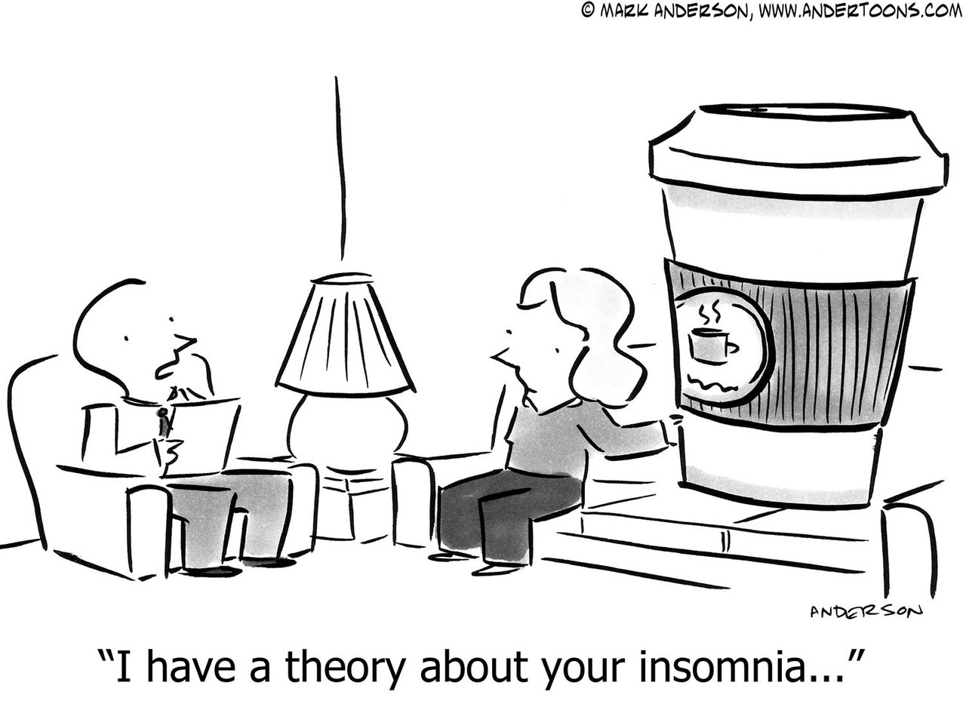

**Introduction to Digital Humanities**

## HIST 6306-001

Wednesday, 2:00pm-4:50pm, 221 Annette Caldwell Simmons

Professor Bianca Lopez

This course surveys recent historical studies of epidemics, from the ancient Antonine plague to Covid-19 with an emphasis on emerging methodologies in digital history. Through looking at how historians are currently analyzing data related to disease through digital tools, we will begin to understand the possibilities for using such tools in our own research. For instance, we look at how scholars digitally map the spread of disease and use visualization programs to communicate raw data to others. Relevant applications and programs will be introduced throughout the course, giving students the opportunity to use and gain expertise in each platform. The course will conclude with a final research project utilizing one digital methodology explored in the course.

**Readings include:** 1) John Hatcher, *The Black Death: A Personal History*; 2) *The Diary of Samuel Pepys;*3)Elizabeth A. Fenn, *Pox Americana: The Great Smallpox Epidemic of 1775-82*.

**Topics in Chinese History**

**Economic History of Postwar Asia (Or How Asia Grew Rich)**

**HIST 6392-001**

Thursday, 2:00pm – 4:50pm, 70 Dallas Hall

Professor Macabe Keliher

Reading seminar on the economic institutions and development of Asia since 1950. Focuses on the growth stories of Japan, Korea, Taiwan, and China and how the region grew so rich so quickly. Examines traditional explanations and weighs their explanatory power against recent exposés of the global cold war and the opening of American markets. Will familiarize students with the founding texts of the field, as well as the recent historiography representing the East Asia archival turn asking new questions and offering novel answers to old questions.

**Readings include**: Amsden, *Asia’s next Giant;* Johnson, *MITI and the Japanese Miracle;* Lie, *The Political Economy of South Korea;* Vogel, *The Four Little Dragons;* Wade, *Governing the Market;* Wu, *The China Development Model*.

**Transnational Research:**

**Global Transformations**

**HIST 6397-001**

Tuesday, 10:00am-12:50pm, 70 Dallas Hall

Professor Neil Foley

This research course is designed for graduate students to conduct primary research and prepare a paper in their area of interest, paying particular attention to the intersectionality of ethnicity/race, gender, class, sexuality, and religion in addressing questions of citizenship and (trans)national identity in regional, national, or global context. We will also explore the ways in which history, custom, culture, politics, and law shape national and transnational identities based on changing concepts of citizenship, racial formations, and patterns of regional and global migration. Students prepare a 30-35-page research paper based on primary sources, write short response papers to the readings, and spend the remaining weeks conducting research and meeting individually with the instructor. During the final three weeks of the semester, we will “workshop” each student’s paper draft and provide detailed written feedback before submitting final drafts at the semester’s end.

**Courses Requiring Department Approval**

(For approval, see Graduate Director)

|  |  |  |
| --- | --- | --- |
| HIST 6049 | Grad Full Time | Crista DeLuzio |
| HIST 6398 | Thesis | Advisor Arranged |
| HIST 6399 | Thesis | Advisor Arranged |
| HIST 7000 | Teacher Preparation | Advisor Arranged |
| HIST 8049 | Grad Full Time PHD | Crista DeLuzio |
| HIST 8398 | Dissertation PHD | Advisor Arranged |

**History Faculty**

|  |  |  |
| --- | --- | --- |
| P04 | Sabri Ates | Associate Professor; |
| P88 | Rachel Ball-Phillips | Adjunct Lecturer |
| P12 | Katherine Carté | Professor; Altshuler Distinguished Teaching Professor |
| P24 | Crista J. DeLuzio | Associate Professor; Director of Graduate Studies: Altshuler Distinguished Teaching Professor |
| P26 | Melissa Barden Dowling | Associate Professor; Department Chair; Altshuler Distinguished Teaching Professor |
|  |  | Director of Classical Studies |
| P86 | David D. Doyle, Jr. | Adjunct Assistant Professor; Dean, Honors and Scholars Program; Director of the University Honors |
|  |  | Program |
| P10 | Jeffrey A. Engel | Professor; Director, Center for Presidential History |
| P27 | Neil Foley | Dedman Chair in History; Associate Director Clements Center for Southwest Studies |
| P85 | Brian Franklin | Adjunct Lecturer; Associate Director, Center for Presidential History |
| P28 | Andrew R. Graybill | Professor |
| P33 | Rick Halperin | Professor of the Practice of Human Rights; Director, Embrey Human Rights Education Program |
| P38 | Erin R. Hochman | Associate Professor; Director of Outreach |
| P94 | Macabe Keliher | Associate Professor; Director of Undergraduate Studies |
| P41 | Jill E. Kelly | Associate Professor; Altshuler Distinguished Teaching Professor |
| P43 | Thomas J. Knock | Professor; Altshuler Distinguished Teaching Professor |
| P87 | Bianca Lopez | Associate Professor |
| P50  P89 | Alexis M. Mccrossen  Pablo Mijangos y Gonzalez | Professor  Professor; Edmund J. and Louise W. Kahn Chair in History |
| P96  P99 | Brandon Miller  Sarath Pillai | Adjunct Lecturer; Assistant Dean of the University Honors Program and Fellowships  Pye Visiting Assistant Professor |
| P02 | Ariel Ron | Associate Professor, Director, Clements Center for Southwest Studies |
| P93 | Kathleen A. Wellman | Professor; Dedman Family Distinguished Professor and Altshuler Distinguished Teaching Professor |
| P84 | Laurence H. Winnie | Senior Lecturer |