SAS 9.4 Installation Guide
Contents:
- Overview
- Definition of Terms
- Installation Notes
- Installation Steps with Screen Shots
- Helpful Information

- Overview:
If migrating from a previous version of SAS, please read all vendor documentation and follow the recommended steps for your current version and the associated upgrade process.
http://support.sas.com/rnd/migration/utility/upgrade.html
Make sure to back up any data files before installing and uninstalling any software.
- Definition of Terms:
SAS Software Depot
The SAS Software Depot is a centralized disk copy of the SMU installation media.
SAS Deployment Wizard
SAS Deployment Wizard will invoke a process that configures and installs the SAS software from the SAS Software Depot.
SAS Installation Data file (SID file)
The SAS Installation Data file consists of customized installation information and product authorization information. The SAS Deployment Wizard uses the installation information in the SID file to install your licensed software and apply customized product authorization information to your system. The file is named something like sas92_xxxxxx_yyyyyyyy_zzz.txt, where xxxxxx is your order number, yyyyyyyy is your setnumid (a unique identifier that Tech Support uses), and zzz is the operating system the order is licensed for. The SID file for your software (order) will be located in the sid_files directory at the root of your SAS Software Depot or, if you have received media, on the first disk of that installation media.

SASHOME
SASHOME is the file location where your SAS software is installed on a machine. SASHome is determined when you install software through the SAS Deployment Wizard the first time, and that location becomes the default installation location for any other SAS software you install on the same machine. For Windows 7 this location is C:\Program Files\SASHome.

- Installation Notes
! Please have your system connected with a power supply, as this installation can take an hour or more to complete for a basic installation, up to several hours for installations with additional components selected!
Note about UNIX Windowing Environments
If you are installing your software on a UNIX system, make sure that a windowing environment—such as X11—is installed. The SAS Deployment Wizard has a graphical user interface.
System requirements – Windows
Please visit the following links for a complete list of Windows system requirements:
http://support.sas.com/documentation/installcenter/94/win/index.html

Installing on UNIX as root
If a Java installation is performed under the root account on HP-UX or Solaris, the Vital Product Registry will not be created. This may cause future installations to fail or to be incomplete. SAS strongly recommends performing all installations under a “SAS” account, and that the root account not be used.

- New Installation Steps with Screen Shots (upgrades may deviate)
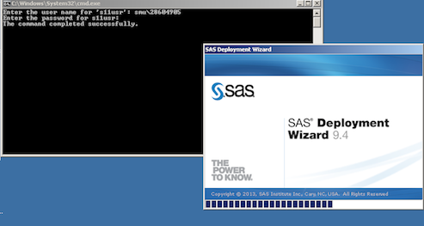
After initiating the SAS.bat file and providing your SMU credentials, the SAS Deployment Wizard will be launched. Please note that there may be a significant delay (up to several minutes) for each screen to appear.

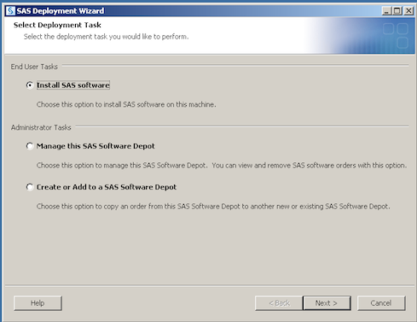
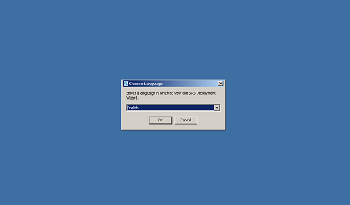
Choose your preferred language for the setup process, click “OK

Select “Install SAS Software”
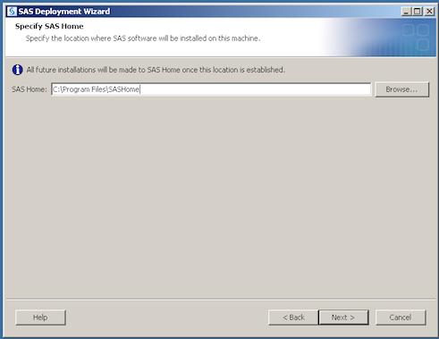

Choose “Next” to accept the default SAS Home directory location

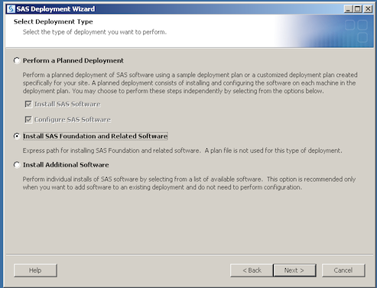
Specify “Install SAS Foundation and Related Software”

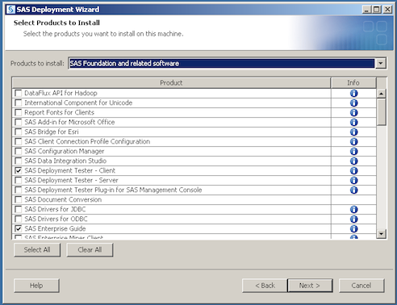
Choose “Next” For a basic SAS installation, or select additional components as needed. Note that additional components will extend the installation time considerably. Clicking on the “i” in the info column will show additional information for each component.

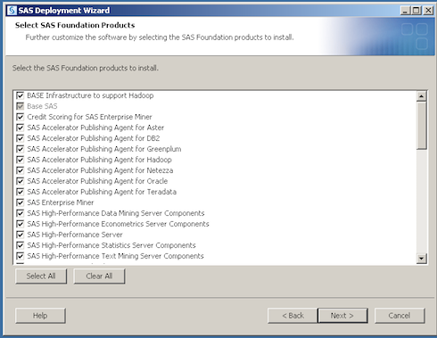
By default all components for installation will be selected. Click “Next”.

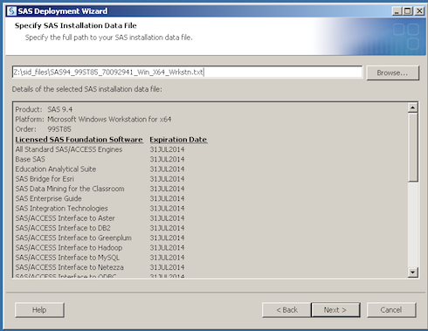
You will see the upcoming expiration dates for the current SID file used in this deployment. See “Helpful Information” below on how to renew these after the expiration date. Click “Next”.

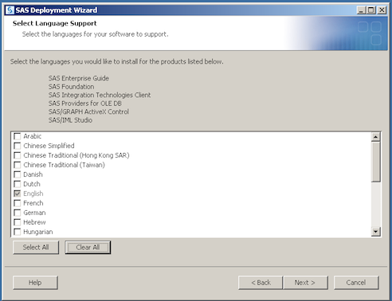
Click “Clear All” or specify an alternate language preference.
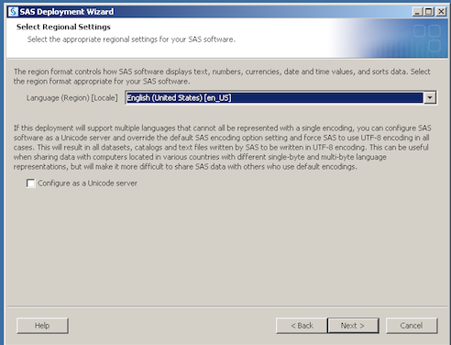

Click “Next” for current regional settings.
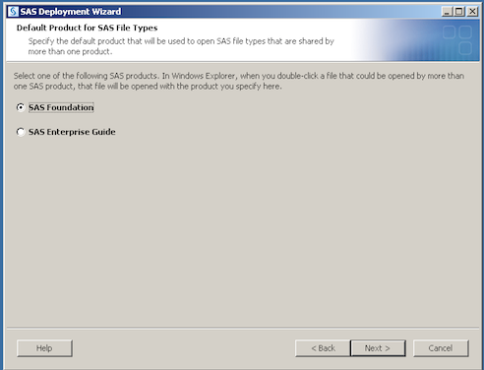
Select “Next” to continue with the SAS Foundation installation.

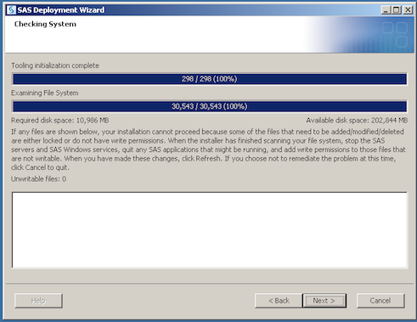
Click “Next” to begin the systems requirements portion of the installation.
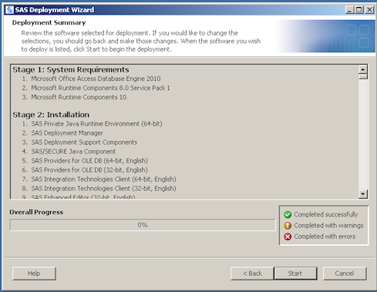

Review your selections and select “Start” to begin the installation.

This will have launched the Installation. This may take up to an hour or more to complete, depending upon your network connection, and the configuration levels that have been selected.

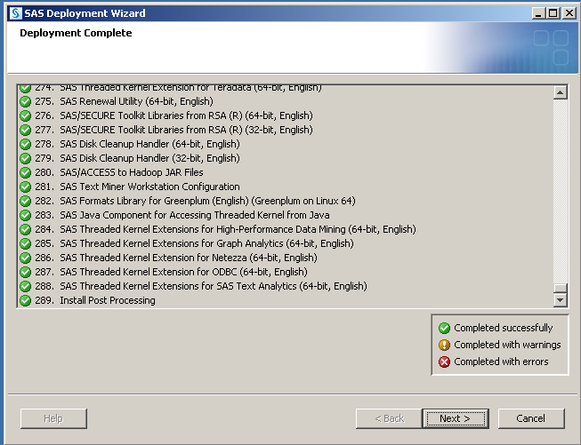
Select “Next” at the completion screen.

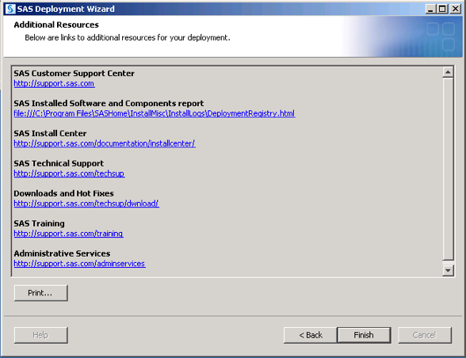
Click “Finish” to complete the installation.

- Helpful Information
Software Expiration
SID files will need to be downloaded each year as the software licensing for SAS is renewed. You can download a new SID file from the sid_files directory found in the Software Depot. Located at https://securenet.smu.edu/+CSCOE+/logon.html . Copy this file to your desktop, and then launch the SAS License Renewal Wizard from the All Programs->SAS->SAS 9.3 License Renewal and Utilities. When prompted, browse to the SID file saved to your desktop to import it to update your SAS installation.
Technical Support and Additional Resources:
http://support.sas.com/documentation/94/

SMU Helpdesk:
Email: help@smu.edu
Call: 214-768-help
Online: https://remotesupport.smu.edu/

